**Chapter-6 (Practice Questions Lecture-22 )**

1. Show the decoding logic for each of the following codes if an active-HIGH (1) output is required: (a) 1101 (b) 1000 (c) 11011 (d) 11100
2. Solve above Problem, given that an active-LOW (0) output is required.
3. You wish to detect only the presence of the codes 1010, 1100, 0001, and 1011. An active-HIGH output is required to indicate their presence. Develop the minimum decoding logic with a single output that will indicate when any one of these codes is on the inputs. For any other code, the output must be LOW.
4. If the input waveforms are applied to the decoding logic as indicated in Figure 6–76, sketch the output waveform in proper relation to the inputs.

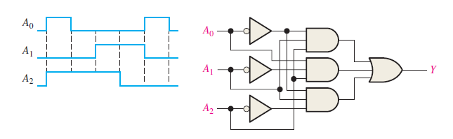

1. BCD numbers are applied sequentially to the BCD-to-decimal decoder in Figure 6–77. Draw a timing diagram, showing each output in the proper relationship with the others and with the inputs.

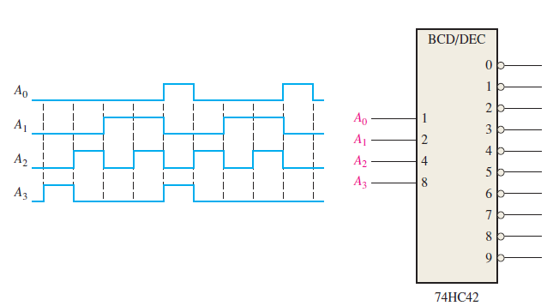

1. A 7-segment decoder/driver drives the display in Figure . If the waveforms are applied as indicated, determine the sequence of digits that appears on the display.

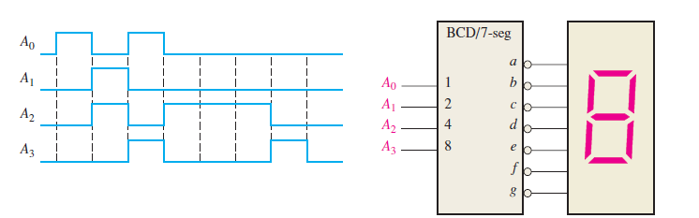

1. For the decimal-to-BCD encoder logic of Figure, assume that the 9 input and the 3 input are both HIGH. What is the output code? Is it a valid BCD (8421) code?

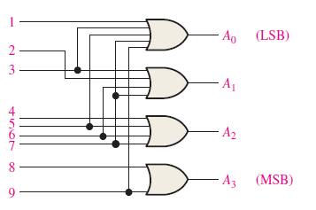

1. A 74HC147 encoder has LOW levels on pins 2, 5, and 12. What BCD code appears on the outputs if all the other inputs are HIGH?
2. Design a logic circuit whose output is High only when a majority of inputs A, B and C are Low.
3. Design a circuit that produced a HIGH out only when all three inputs are at the same level.
4. The notataion x1 x0represents a two-bit binary number that can have any value (00, 01, 10,11); for example , when x1= 1, x0 = 0 , the binary number is 10, and so on. Similarly y1, y0 represent another two-bit binary number. Design a logic circuit, using x1,x0,y1, and y0 inputs , whose output will be HIGH only when the two binary numbers x1 x0 and y1 y0 are opposite.
5. A four-bit binary number is represented as A3, A2, A1, A0, where A3 , A2, A1 and A0 represent the individual bits and A0 is equal to the LSB. Design a logic circuit that will produce a HIGH out put whenever the binary number is greater than 0010 and less than1000.
6. Write the function table for a half subtractor ( input A and B, output DIFF and CARRY). From the function table, design two logic circuits that will act as half subtractor.
7. Derive an expression for 2-bit magnitude comparator using Table.

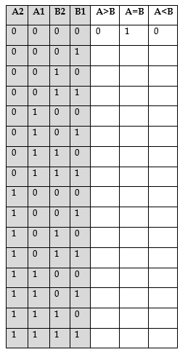

1. A BCD-to-seven-segment decoder is a combinational circuit that converts a decimal digit in BCD to an appropriate code for the selection of segments in a display indicator used for displaying the decimal digit in a familiar form. The seven outputs of the decoder (a, b, c, d. e,j, g) select the corresponding segments in the display, as shown in Fig. P4-l6(a). The numeric designation chosen to represent the decimal digit is shown in Fig. P4-16(b). Design the BCD-to-seven-segment decoder using a minimum number of NAND gates. The six invalid combinations should result in a blank display.

